Explorer Project

My explorer is ___________________________________.

Calling All Explorers!

The time has finally come for you to complete your own explorer project. You will create a stunning report on your explorer using class time as well as time at home. You will need to research information carefully and provide maps, flags, and pictures to really make your report outstanding. Finally, you will present your report to the class for us all to learn and enjoy. The completed report is due Tuesday, March 28, 2017. Presentations will be from March 28th -30th. Below is a sample pacing guide.

3/20 Complete research notes
3/22 Complete map
3/23 Complete flag and picture or explorer
3/27 Finalize presentation
3/28-3/30 Present to the class

Research Notes (Before You Do Anything Else):
- When available, includes birth date, birthplace, and death date 10pts
- Tells all about the explorer’s “Early Years” and/or life outside of exploring 40pts
- Tells all about the explorations of the explorer 50pts

Map:
- Hand-draw your explorer’s route(s) 10pts
- Hand-colored map 10pts
- Label countries and bodies of water the explorer traveled through 10pts
- Include at least 2 hand-drawn illustrations, such as a ship, compass, gold, astrolabe, etc. 10pts
- Include a map key or legend that identifies the illustrations as well as the explorers routes 10pts

Flag and Picture of Explorer:
- Flag of the explorer’s home country OR country he/she sailed for 10pts
- Self-colored flag and picture 10pts
- Includes the name of the country 5pts

Oral Presentation:
  - Name your explorer and show/display a picture of him (note: you will not have your report) 4pts
  - Include when and where he was born and died 4pts
  - Include why he was important 4pts
  - Presentation is 2 – 4 minutes long 4pts
  - Use a clear, strong voice 3pts
  - Good eye contact 3pts
  - Use note cards or memorize presentation 3pts
  - OPTIONAL: add another visual (Google Slides, poster, video, dress up as your explorer, etc.)

Bibliography (Extra Credit) 10 points: Include at least 3 sources and number each source

S. S. Explorer Report Grade Sheet

Pts. Possible Your Assessment Pts. Earned

Research Notes 100 _________ _________

Map 50 _________ _________

Flag/Explorer Pic. 25 _________ _________

Presentation 25 _________ _________

Bibliography Bonus _________ _________

TOTAL POINTS (200 Total) ________

As you learn more about your explorer, use the map below as a rough draft to show the routes of your explorer.

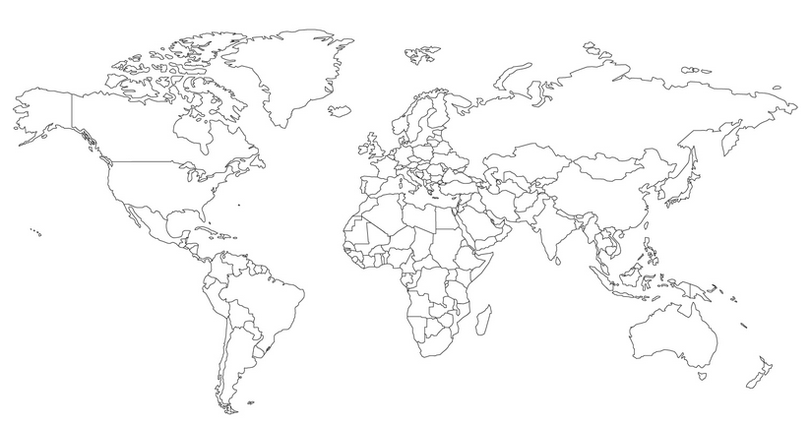

Explorer Report Notes:
Use this guide to collect information about the explorer.

BACKGROUND INFORMATION (Introduction Paragraph)

Date of birth: _________________________

Date and place of death: _____________________________________________________________________

Birthplace: ________________________________________________________________________________

Country your explorer represented: _____________________________________________________________

Years during which your explorer traveled: ______________________________________________________

Name of ship or ships (if available): ____________________________________________________________

Your explorer’s goal of his voyage: _____________________________________________________________

__________________________________________________________________________________________

__________________________________________________________________________________________

EVENTS OF EXPLORER’S LIFE
Remember to include dates whenever possible

Early Life (Here are some possible questions to help you research: Where did he live? Did he always live there? Did he go to school? Did he have siblings? What happened before he became an explorer?):

__________________________________________________________________________________________

__________________________________________________________________________________________

__________________________________________________________________________________________

__________________________________________________________________________________________

__________________________________________________________________________________________

__________________________________________________________________________________________

__________________________________________________________________________________________

__________________________________________________________________________________________

__________________________________________________________________________________________

__________________________________________________________________________________________

__________________________________________________________________________________________

Voyages (Here are some possible questions to help you research: Which county sponsored his journey? Did your explorer make any new discoveries? Which areas did he explore? What contributions did his journey do for the world? What were the consequences of his journey? What interesting facts did you find out about him? Why is he important?)

__________________________________________________________________________________________

__________________________________________________________________________________________

__________________________________________________________________________________________

__________________________________________________________________________________________

__________________________________________________________________________________________

__________________________________________________________________________________________

__________________________________________________________________________________________

__________________________________________________________________________________________

__________________________________________________________________________________________

__________________________________________________________________________________________

__________________________________________________________________________________________

__________________________________________________________________________________________

__________________________________________________________________________________________

__________________________________________________________________________________________

__________________________________________________________________________________________

__________________________________________________________________________________________

__________________________________________________________________________________________

__________________________________________________________________________________________

__________________________________________________________________________________________

__________________________________________________________________________________________

__________________________________________________________________________________________

__________________________________________________________________________________________

__________________________________________________________________________________________

__________________________________________________________________________________________

